Find the resultant vector in the following situations. Use the origin given below to plot the final x and y vectors and find the resultant

A drone has a velocity of 45 m/s @ 30 ° and the wind has a velocity of 12 m/s at 110°. What is the resultant velocity of the drone?

|  |  |  |  |
| --- | --- | --- | --- |
| Vector source | Vector | X component  Cos θ (v) | Y component  Sinθ (v) |
| Drone | 45 m/s @ 30° | 39.0 x | 22.5 y |
| Wind | 12 m/s @ 110 | – 4.1 x | 11.3 y |
| Net |  | 34.9 x | 33.8 y |

Vr = 48.6 @ 44.0°

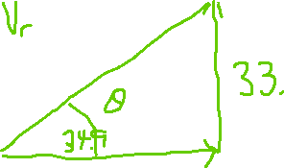

**+**

A boat has a velocity of 35 m/s @ 20° while the wind blows at 15 m/s at 90° and the water flows at 5 m/s at 210°. Find the resultant velocity of the boat.

|  |  |  |  |
| --- | --- | --- | --- |
| Vector source | Vector | X component  Cos θ (v) | Y component  Sin θ (v) |
| Boat | 35 m/s @ 20° | 32.9 x | 12.0 y |
| Wind | 15 m/s @ 90° | 0 x | 15.0 y |
| Water | 5 m/s @ 210° | – 4.3 x | – 2.5 y |
| Net |  | 28.6 x | 24.5 y |

Vr= 37.7 @ 40 .6°



