1. A person runs 320 m at 30°, turns and jogs 400 m at 120° and then runs 250 m at 210 °. Find the components of each vector, find the net x and y vectors of this displacement, and then find the resultant displacement.

|  |  |  |  |  |
| --- | --- | --- | --- | --- |
| Vector | x component | Y component | Resultant | Angle |
| V1 320 @30° | Cos (30 )(320)  277 x | Sin(30)(320)  160 y |  |  |
| V2 400 @ 120° | Cos 120 (400)  – 200 x | Sin 120 (400)  346 y |  |  |
| V3 250 @210° | Cos 210(250)  – 217 | Sin 210(250)  – 125 |  |  |
| Net | – 140 x | 381 y |  |  |

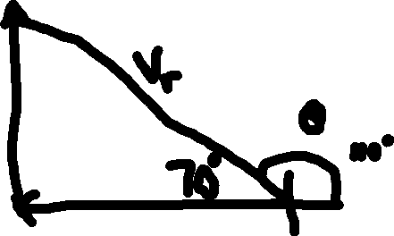

Vr = (1402 + 3812)1/2 @ tan-1 (381/140)



406 m @ 110°

1. A boat sails at 12 m/s on a course of 40° for 5 min, changes course to 150° and sails for 5 minutes at 15 m/s, and finally turns on a course of 60° and sails for 5 minutes at 8 m/s. What is the net displacement of the ship after 15 minutes? (Use speed and time to find displacement for each leg, then find components, net x and y and finally the resultant displacement.

12 m/s (60 s/1min) ( 5 min) = 3600 m at 40°

15 m/s (60 )(5) = 4500 m @ 150°

8 m/s (60)(5) = 2400 m @ 60°

|  |  |  |  |  |
| --- | --- | --- | --- | --- |
| Vector | x component | Y component | Resultant | Angle |
| V1 3600 @ 40° | Cos (40) (3600)  2758 x | Sin(40)(3600)  2314 y |  |  |
| V2 4500 @ 150° | Cos 150 (4500)  – 3897 x | Sin 150 (4500)  2250 y |  |  |
| V3 2400 @ 60° | Cos 60 (2400)  1200 x | Sin 60 (2400)  2078 y |  |  |
| Net | 61 x | 6642 y |  |  |

Vr = (612 + 66422)1/2 @ tan-1 (6642/61) 6642.3 @ 89.5°

