Draw a free body diagram for each of the following situations.

A person uses a rope to pull a crate across a rough floor to the right and they apply the force parallel to the ground.

A worker pulls the crate across a smooth floor to the right at an upward angle of 30° to the horizontal.

A worker pushes the crate on a rough floor to the right with the force applied parallel to the ground.

A worker pushes the crate to the right on a rough floor with the force being directed at a downward angle of 20° below the horizontal.

A pair of workers pull the crate across a rough floor, one of them pulls on a rope parallel to the ground while the taller one pulls the crate at an upward angle of 20 °.

A crate is sliding across a rough floor and slowing down.

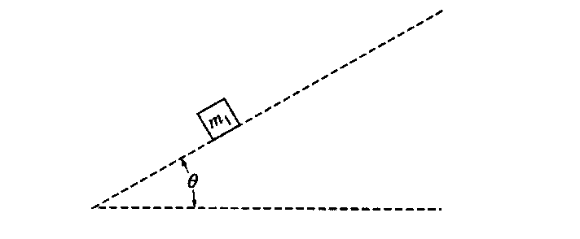
A crate sits motionless on a rough incline.
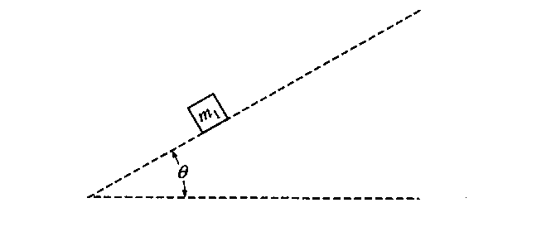
A crate is pulled up a rough incline with the force being applied parallel to the incline.

