Forces Review/Summary Sheet
There are two different cases we dealt with regarding forces. The case where there is a net force, F_{net}, acting on an object and Newton’s 2nd Law tells us that the net force will cause the object to accelerate in the direction of the net force.
Newton’s 2nd Law: ΣF = F_{net} = ma
If there is no friction, then F_{net} = ma as the applied force is the only force acting on the object. We then looked at three different situations where we applied a force to an object.
The object is sitting on a level surface and has a force applied in one direction:

In this case, the three forces acting on the crate are weight and Normal force, which are equal to each other, and the applied force from a push or pull to the right.
ΣF_{y} = 0 = N – mg (up minus down) so that mg = N
In the x direction: ΣF_{x} = ma = F_{pull}
We also looked at situations where the applied force was NOT parallel to the level surface:

In this case, the applied force has a y component, (sin ϴ)( F_{app}) as well as an x component, (cos ϴ)(F_{app}). This F_{x} will be the force that can cause motion of the object to the right.

This situation will also change the value of the Normal force.
ΣF_{y} = 0 = N + F_{y} – mg (up forces minus down forces) so that
N = mg – F_{y} The upward part of the applied force counteracts some of the weight so that the floor does not have to support all the weight, making Normal force smaller than mg.
We also looked at objects sitting on an incline. In this situation, the forces that act on the object are the weight and the Normal force (without friction).
The weight of the object has two components, one that is perpendicular to the incline, and INTO the Plane. While one is parallel to the incline and goes down the plane. The angle between weight and the red vector, F_{perpendicular} is the same as the angle of the incline. The red vector is adjacent to the angle while weight is the hypotenuse. The green vector, F_{ll}, is opposite the angle so sin is used to calculate its value.

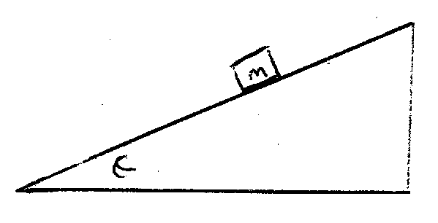

The F_{ll} will be the component of weight pulling the mass DOWN the incline and the perpendicular force will be equal to Normal force, which will be used to find friction when we add it.

In this situation, ΣF_{x} = ma = F_{ll} if we were to add friction, then the ΣF_{x} = ma = F_{ll} – f.
In the situations where our object is on a level surface, the Sum of forces statement will be similar.

ΣF_{x} = ma = F_{app} – f ΣF_{x} = ma = F_{x} – f
ΣF_{y} = 0 = N + F_{y} – mg
Also recall that μ, the coefficient of friction¸= f/Normal force.
So friction can be calculated by (μ)(N). Also remember that when an object moves at constant velocity, acceleration is zero so f = F_{app} or F_{x}

