Impulse notes handout and examples
Often when objects collide, it is difficult to determine the exact value of the force that is involved and it is also hard to measure the actual amount of time the collision takes. Think about a pair of billiard balls colliding, or think about all the balls colliding when a player “breaks” the rack of pool balls at the start of the game. When the collision takes place, it is often very short lived, and sometimes the forces involved can be very large.
Because the force and the time are often difficult to measure precisely, we can look at the overall impact that these two factors have on an object’s momentum. Looking at the definition of momentum below:
F = Δp
Δt
You see that if we multiply both sides by Δt we get:
FΔt = Δp = mΔv = m(v_{f} – v_{o})
This is known as the impulse momentum equation, or theorem, and it allows us to look at the combined effect of the product of the average force and time on an object’s momentum. The product F Δt is known as impulse. Impulse is given the symbol J, and our formula becomes:
J = F Δt = m(Δv) = m(v_{f} – v_{o})
When objects collide, how do the forces experienced by each object compare? Are they the same? Why or why not?
Due to the fact that the forces between objects are the same, according to Newton’s third law, the impulse resulting from a collision between two objects will be felt by both objects that collide. Because the impulse involves forces, which are vectors and can be positive or negative due to direction, the impulse on an object can also be positive or negative.
Ex 1:
Cart 1 of mass 0.500 kg moves to the right at a velocity of 5 m/s and collides with Cart 2 that has a mass of 0.500 kg travelling to the left at 2.0 m/s. After the head on elastic collision, Cart 1 is travelling to the left at 2.0 m/s, and Cart 2 is travelling to the right at 5.0 m/s.
Look at the impulse that acted on Cart 1.
J = m(v_{f} – v_{o})
J = (0.500 kg)(– 2.0 m/s – 5.0 m/s) = – 3.5 N ∙ s
(N ∙ s is the same unit as kg m/s for momentum)
(Kg m/s²)s = kg m/s or
(N ∙ s) = kg m/s
Look at the impulse that acted on Cart 2.
J = m (v_{f} – v_{o})
J = 0.500 kg (5.0 m/s – (– 2.0 m/s) = + 3.5 N ∙ s
Notice that the impulse is the same, but one of the objects experiences a negative change in velocity and momentum, and the other has a positive change in velocity and momentum.

Ex 2:
Let’ say that the collision above took 0.003 s to occur. Find the force involved in the collision.
J = F Δt = m(v_{f} – v_{o})
The magnitude of the force can be found directly from the value of the impulse or from the mass and velocity data.
J = 3.5 N ∙ s = F t = F (0.003 s) F = 3.5 N ∙ s/ (0.003 s) = 1167 N
The Impulse on Cart 1 was negative, so the Force will be negative. The Cart was moving right and ended up moving left, so the force must have been opposite its motion, in the negative direction, so it would have a negative value. For Cart 2, it went from moving in the negative direction to the positive direction, so the force must have been in the positive direction.
Ex 3:
A 0.30 kg billiard ball moving 2.0 m/s in the positive direction collides elastically head-on with a ball that has a mass of 0.70 kg that is at rest. After the collision the 0.70 kg ball is moving at 1.2 m/s in the positive direction.
Determine the velocity (speed and direction) of the 0.30 kg ball after the collision.
Determine the impulse experienced by the balls during the collision.
If the time for the collision to occur is 0.0015 s, determine the Force that acted on the 0.30 kg ball.
Determining the net impulse can also be done using a graph of the force involved in a collision (or the force that acts on a single object) vs time that the force acts.
Ex 4
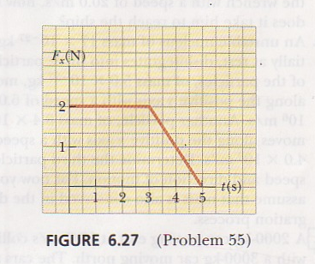
A 4.0 kg object is initially at rest and it is subjected to a force as shown in the diagram above.
Determine the net impulse that acts on the object.

Once the impulse is known, plug into the impulse momentum theorem to determine the change in momentum or velocity.

J = m(v_{f} – v_{o}) = 4.0 (v_{f} – 0) = 4v_{f}

J = (2x3) + ½ 2(2) = 8 N∙ s /4 kg = 2 m/s
When two objects collide, a graph could look like the following:
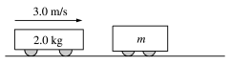
A 2.0 kg cart is moving right at 3.0 m/s as shown above. It will collide with a cart of unknown mass that is initially at rest. The force of the collision as a function of time is shown below. As a result of the collision the the stationary cart acquires a velocity of 2.0 m/s to the right.
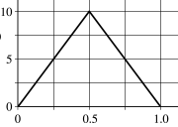
Calculate the impulse experienced by each cart.
Is the impulse on cart #1 positive or negative?
Determine the final velocity (speed and direction) of cart # 1after the collision.

Determine the mass, m, of cart number 2.

