Ray tracing to find an image with lenses

When light passes through a lens an image will be formed. The location of that image depends upon the type of lens as well as the location of the object we are looking at through the lens. There are two basic types of lens: a lens that converges light (converging lens) and light that makes light diverge (spread out), or diverging lenses.
Lenses work by refracting light that travels from the air into and through the glass which has a higher index of refraction.

(Expanded view of lens refraction)

The two types of lenses can be recognized by their shape. Lenses have different thicknesses at their edges and center and are curved on at least one side.
Lenses that are thicker in the center than on the edge are Converging Lenses. They have a Convex shape (curve outward) Convex – Converge
Lenses that are thinner in the center than on the edge are diverging lenses and are concave. To tell the difference just remember Convex-Converge

There are two types of lenses that can be produced by lenses (or mirrors). Real images are images that can be projected onto a screen, and virtual images are images that cannot be touched or projected into the physical world. Virtual images exist only in a virtual world that cannot be touched.
With Lenses, real images appear on the opposite side of the lens from the object.
Virtual images appear on the same side of the lens a the object (like a magnifying glass)

To locate the images that are formed we use a method called ray tracing.
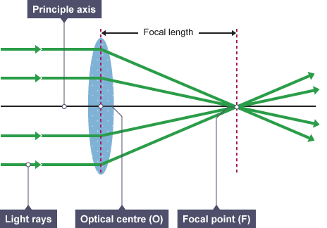
Light rays that enter a lens parallel to the principle axis are all converged at the focal point of the lens on the other side of the lens.
To find the location of an image we need to trace three rays of light from our object through the lens and out through the focus on the other side. We trace rays from the top of the object to show where the top of the image will appear, and then know that for every other point on the object, light rays would behave in the same fashion, giving us the full image.
Ray one – From the top of the object to the lens (parallel to the principle axis) and out through the focus.
Ray Two – From the top of the object through the center of the lens and out (A diagonal line)
Ray 3 – From the top of the object through the focus on the same side of the lens, to the lens and out parallel to the principle axis.
Where these three rays intersect will be where the image is formed.
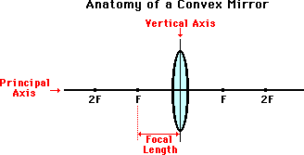
The placement of the object will have an impact on the characteristics of the image formed.
In the above Case, the object is outside the focus of the lens. The image formed is inverted (upside down) and can be enlarged or reduced (bigger or smaller) based upon the distances involved. The actual numbers are related through the thin lens equation;
1 + 1 = 1
d_{i} d_{o} f
Any time the object is outside the focus, the image will be real and inverted. The magnification of the image will be calculated by using m = – d_{i}/d_{o} (The negative sign will take into account the inverted image. If the magnification is negative the image is inverted.
If the object is located inside the focal length, the ray diagram becomes trickier.

