N- tipers; Horizontally Launched projectiles
Rifle shots timed to the ground:
Rifles are fired horizontally from platforms at various heights. The bullets fried from these rifles are identical, but they leave the rifle barrels at different speeds as shown in the diagrams. All of the bullets miss their targets and hit the ground. Ignore air resistance.
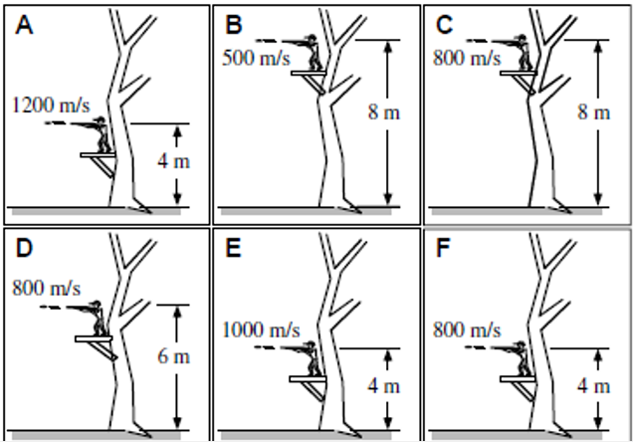
Students are asked to rank these situations on the basis of how long it takes the bullets to hit the ground respond as follows.
Anja: “I think the ranking should be C > B > D > A > E > F because if two bullets are shot from the same height at different speeds, their y-acceleration is the same, meaning the one shot faster would have to cover more of the horizontal distance before hitting the ground, thereby making the time longer. So we first by height then by velocity.”
Brianna: “The Higher the platform, the longer it will take, but the faster the bullet, the smaller the time to hit the ground. So using rate times time = distance we get time = height /velocity, which gives us the ranking B > C > D > F > E > A.”
Charlie: “I think the ranking should be A > E > C > D > F > B. I agree that the height of the platform matters as does the velocity. The faster the bullet is moving, the longer it takes to hit the ground and the higher the longer too. So we rank first by velocity, then by height if the velocities are the same.”
Danielle: “I get B = C > D> A = E = F. The time that each bullet is in the air depends on the initial vertical velocity and the height. Sind the vertical velocity is zero we only need to worry about the height, with the larger height giving the longer time. The horizontal velocity does not matter.”
Ellie: “I think the ranking is A > E > C = D = F > B, since the tie to reach the ground is directly related to horizontal velocity.”
Which, if any, of these students do you agree with?
Anja ____ Brianna ____ Charlie ____ Danielle ____ Ellie ____ None of them ____
Explain.
A military plane is flying 1200 m above the flat ground at a speed of 200 m/s. it drops a practice bomb that hits the ground after travelling a horizontal distance of 3130 m. Ignore air resistance.
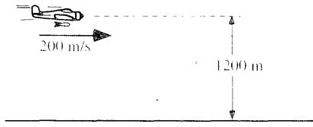
For each of the changes listed below, use the lettered choices below to identify what will happen to the horizontal distance the bomb travels while falling compared to the original situation above.
- The horizontal distance will be greater than 3130 m
- The horizontal distance will be less than 3130 m
- The horizontal distance will be equal to 3130 m
- The horizontal distance will be zero, i.e. the bomb will drop straight down
- We cannot determine how this change will affect the horizontal distance
- The plane’s speed is tripled.
Explain

- The plane is climbing straight up at the release point.
Explain

- The plane is flying level at an altitude of 1100 m
Explain

- The mass of the bomb is increased
Explain

- The bomb is thrown from the plane with a vertical downward velocity of 15 m/s
Explain

- The plane is diving at a 20 degree angle and is at a height of 1200 m when the bomb is released.
Explain

- The plane’s speed decreases and it is flying at an altitude of 1800 m
Explain.

Toy trucks rolling off tables with different heights – Time
Two toy trucks roll off the ends of tables. The heights of the tables, the speeds of the trucks and the masses of the trucks are given.
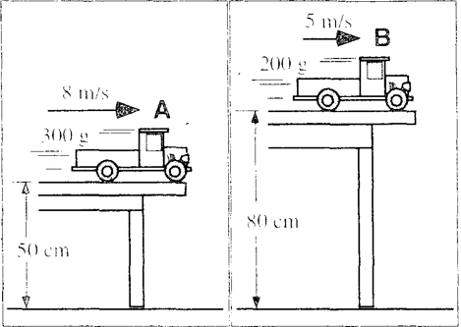

Will truck A be in the air for a longer, as shorter, or the same time as truck B before it reaches the floor? Explain

Toy trucks with different speed rolling off identical tables – time
Two toy trucks roll off identical tables. The speeds and masses of the trucks are given.
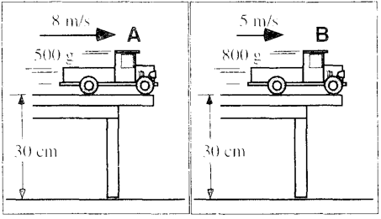
Will truck A be in the air for a longer, as shorter, or the same time as truck B before it reaches the floor? Explain

Projectile motion for two rocks – velocity and acceleration
Two identical rocks are thrown horizontally from a cliff with different velocities. The rocks are thrown at the same time, and are shown after a few seconds. Neglect air resistance.
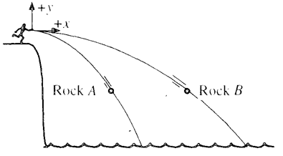
For the instant shown:
- Will the magnitude of the horizontal velocity of Rock A be greater than, less than, or equal to the magnitude of the horizontal velocity of Rock B? Explain.

- Will the magnitude of the vertical velocity of Rock A be greater than, less than, or equal to the magnitude of the vertical velocity of Rock B? Explain.

- Will the magnitude of the horizontal acceleration of Rock A be greater than, less than, or equal to the magnitude of the horizontal acceleration of Rock B? Explain.

- Will the magnitude of the vertical acceleration of Rock A be greater than, less than, or equal to the magnitude of the vertical acceleration of Rock B? Explain.

