N – tipers; Horizontal w/ graphs
Projectile motion- velocity and acceleration graphs for two rocks.
Two rocks are either dropped or thrown at the same time form the same cliff. Graphs for part of the motion of the rocks are shown for a coordinate system in which up is the positive vertical direction and the positive horizontal direction is away from the cliff. The origin is at the point at which the rocks were released. Ignore air resistance.
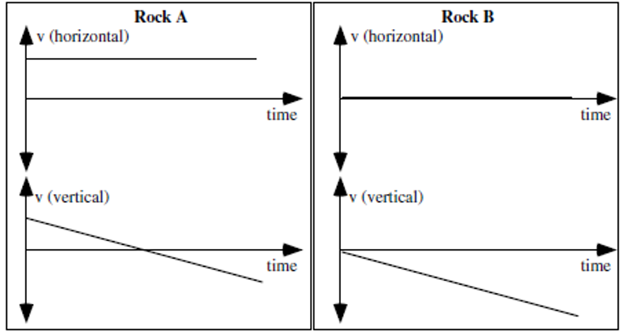
- Is rock A dropped, thrown, or is it not possible to determine whether it was dropped or thrown? Explain

- Is rock A dropped, thrown, or is it not possible to determine whether it was dropped or thrown? Explain.

- Does Rock A hit the ground first, at the same time, or after Rock B? Explain

- Does Rock A hit the ground closer to, at the same distance from, or farther from the base of the cliff compared to Rock B? Explain.

Projectile motion for two rocks- Velocity and acceleration graphs I
Two identical rocks are thrown horizontally from a cliff with Rock A having a greater velocity at the instant it is released than Rock B. For this exercise you should ignore air resistance. Use a coordinate system with up as the positive vertical direction, away from the cliff as the positive horizontal direction and with the origin being at the point of release at the top of the cliff.
- Sketch velocity vs time and graphs for each of the rocks.
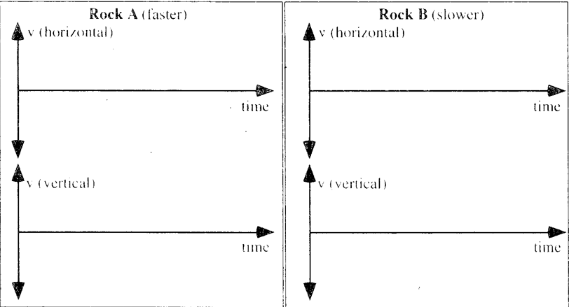

- Which rock hits the ground first?

- Which rock lands furthest from the base of the cliff?

- Explain why you drew the graphs like you did and how you determined your answers.

Projectile motion for two rocks – velocity and acceleration graphs II
Two students throw two rocks horizontally from a cliff with different velocities.
Both rocks hit the water below at the same time but Rock B hits farther from the base of the cliff. For this exercise, you should ignore air resistance. Us coordinates where up is the positive vertical direction, away from the cliff is the positive horizontal direction and the origin is at the top of the cliff at the release point | 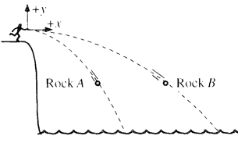
.
Sketch below velocity vs time graphs for each rock.
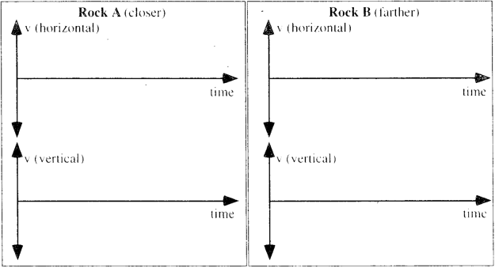
Explain how your determined your answer

Projectile motion for two rocks – velocity and acceleration
Two identical rocks are thrown horizontally form a 60 m tall cliff with initial velocities of 20 m/s and 30 m/s. The rocks are thrown at the same time, and are shown after a few seconds. Neglect air resistance. Use the coordinate system with the origin at the place where the rocks are released and with the directions as shown in the diagram.
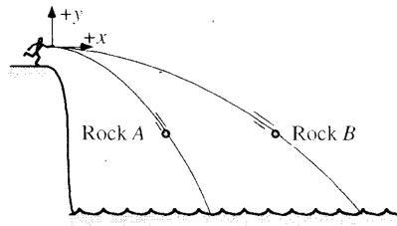
Write the position equations for Rock A, x(t) and y(t) and the velocity equations for rock B, v_{x}(t) and v_{y}(t)
Rock A
x(t) =

y(t) =

Explain

Rock B

V_{x}(t) =

V_{y}(t) =

Explain

